Wednesday 02:30 pm – 04:15 pm
Prefix codes: A prefix code is represented by a binary tree in which the external nodes are labeled with single characters that are combined to form the message. The encoding for a character is determined by following the path down from the root of the tree to the external node that holds that character: a 0 bit identifies a left branch in the path, and a 1 bit identifies a right branch. In the following tree, the code for b is 111 and that of d is 1010.
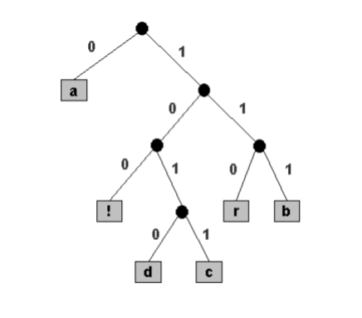
A second fundamental property of prefix codes is that messages can be formed by simply stringing together the code bits from left to right. For example, the bitstring 01111100100 encodes the message “abra!”.
Representing the binary tree: To decode a bit string, you need the binary tree that stores the character encodings. We use the preorder traversal of the binary tree to represent the tree itself. Internal nodes are labeled with the special character ’*’. (For convenience, we restrict ourselves to messages that do not contain this special character.) The preorder traversal of the above tree is: * a * * ! * d c * r b
Input format: The input will consist of the preorder traversal of the binary tree and the compressed message.
Expected Output: The output will be the deciphered message encoded using a prefix code, given the encoding tree.
Q1. [CO6][5 Marks] What will be an appropriate data structure and algorithm design technique to the given problem. Justify.
Q2. [CO4][5 Marks] Analyze your algorithm by its complexity using asymptotic analysis.
Q3. [CO6][10 Marks] Write a program to decipher messages encoded using a prefix code, given the encoding tree.
Test your program with the following inputs:
- *a**!*dc*rb
0111110010110101001111100100
- ** b*a*d*yo
1110100101100011010010110001101111111100

